Pricing

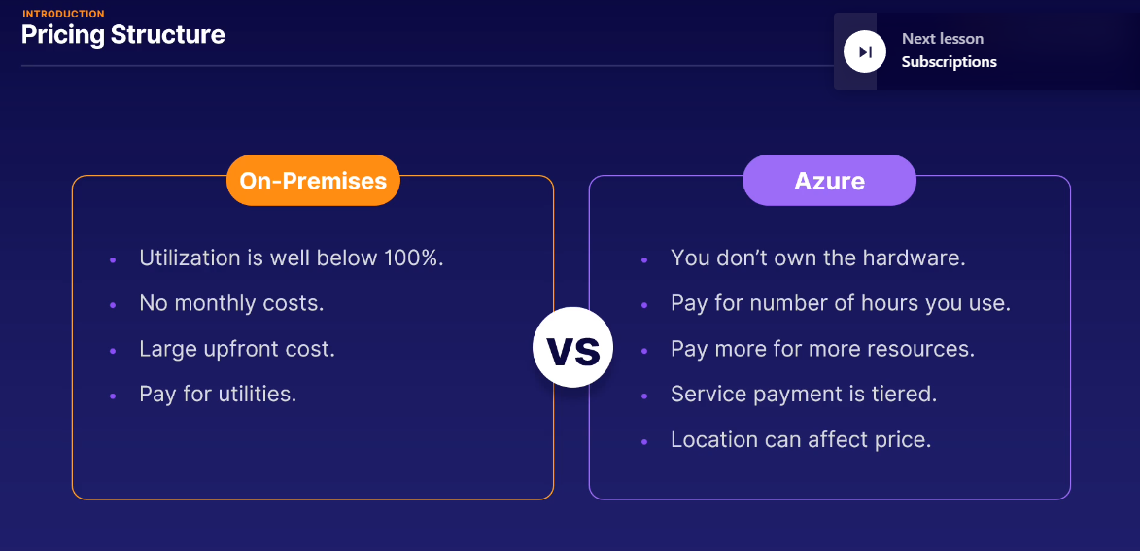

* Every resource on Azure lives within a subscription. Because Microsoft likes to be paid for you using their Azure services
* Subscription is how they send you an invoice.
* There cannot be a service or resource that lives outside of a subscription.
* You can have multiple subscriptions for any Azure account
* We have a user in your organization that has the role of billing admin.
* By billing admin role ensures that users that aren't billing admins won't have access to billing information.
* Billing cycles on Azure are usually monthly and requires payment within 30 or 60 days.

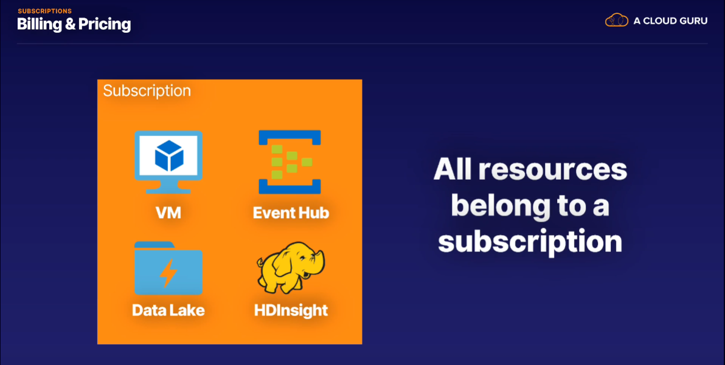

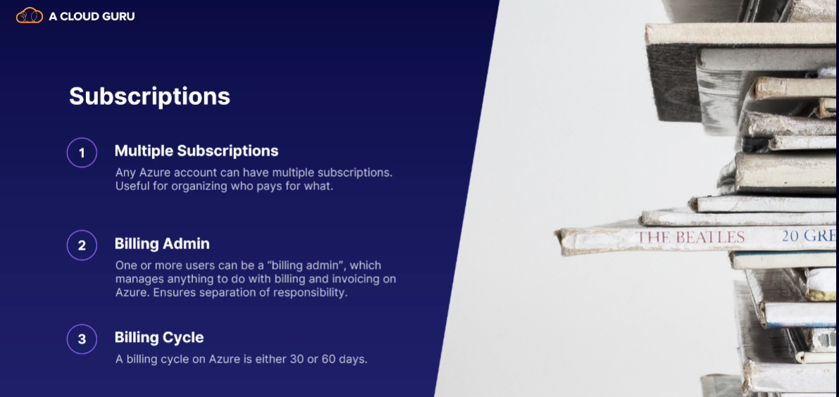

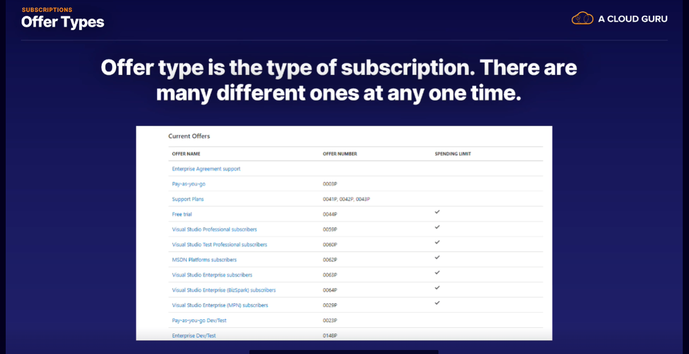

Management groups is useful feature when it comes to subscription.

* We can group our subscriptions.
* Organize (You can manage access, policies, and compliance in multiple subscriptions at the same time.)
* Billing Logic
* You can also nest management groups to indicate a hierarchy.
* Each management group can have a single parent group but many child groups.

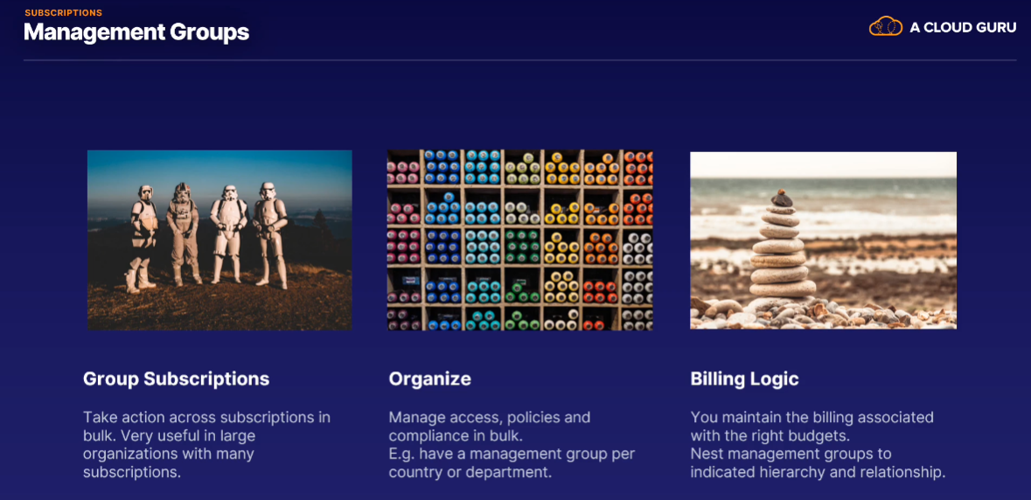

Cost Management:::

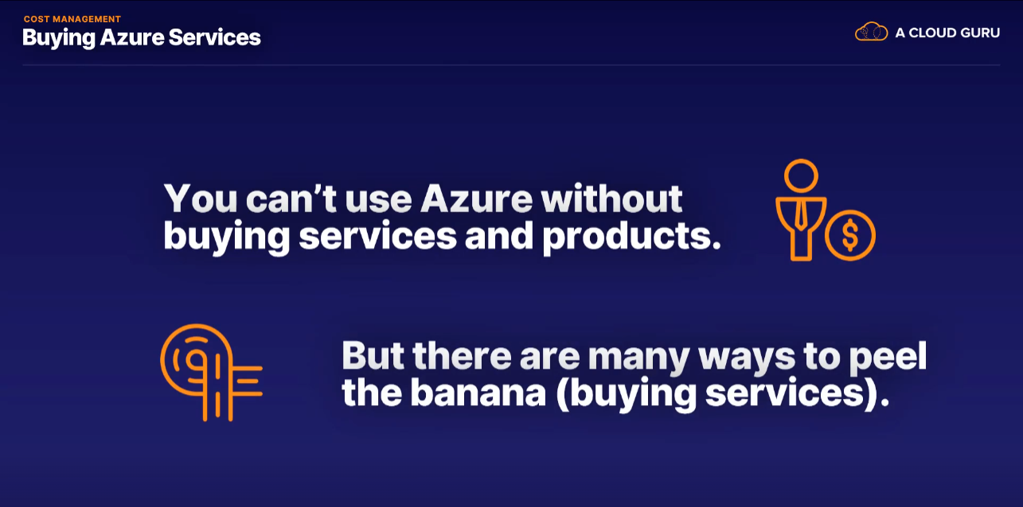

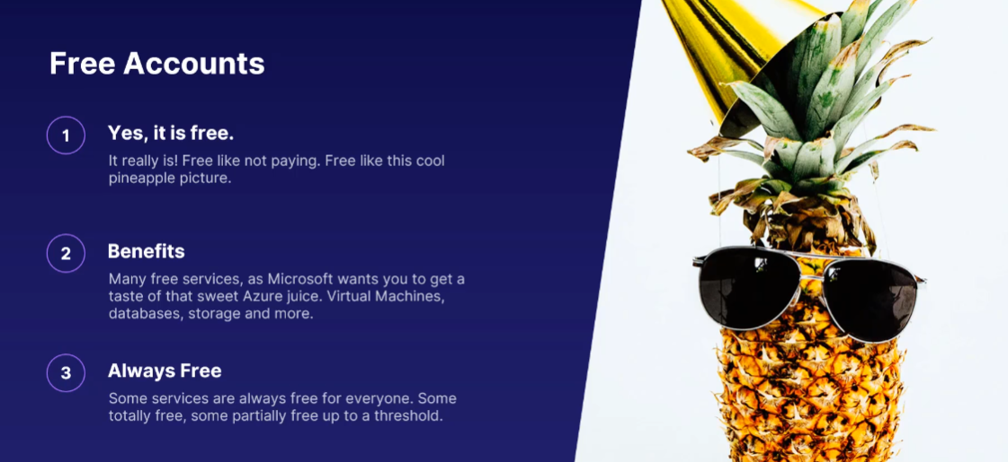

* First created free account (this point is for above pic)
* There is a way to manage your costs by seeing them in Azure Cost Management.
* Azure Cost Management is accessible from the Azure portal.
* You can get a detailed view of the current and projected future costs of all the Azure resources that are within your area of accountability.
* Azure cost management is free and included with all Azure subscriptions.
* You can download reports on spending, get recommendations on how to save costs, and analyze costs in great details.
* You can get the Cost Management tool to optimize your current resources to save you money.
* Can even monitor your AWS spend in the tool as well. This is very useful for your multi-cloud setup.

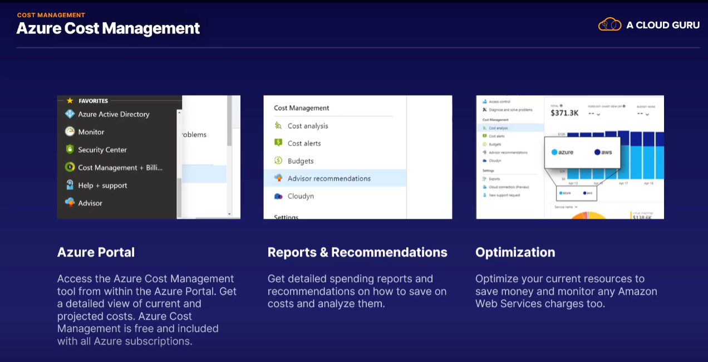

Spot pricing on Azure for virtual machines, is called by Microsoft as deep discounts, which alludes to the fact that you can save a lot on using these Spot instances.

Spot VM::

* A Spot VM, or Spot Virtual Machine, is a virtual machine that can be created and run at a significantly reduced cost.
* You save up to 90% off the price by choosing to use a Spot VM.
* You aren't guaranteed they will run forever. (they may have chance to gone)
* Azure can remove your VM at any time they need the compute capacity back.
* Don't put any critical production processes on a Spot VM.

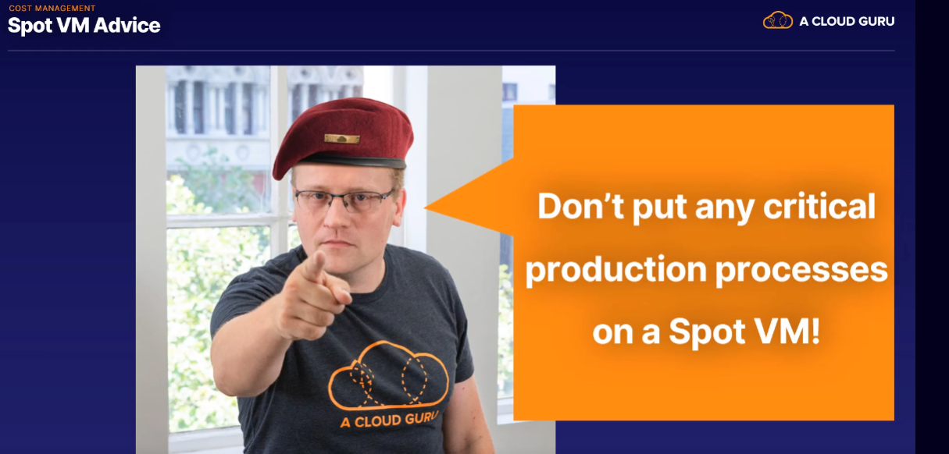

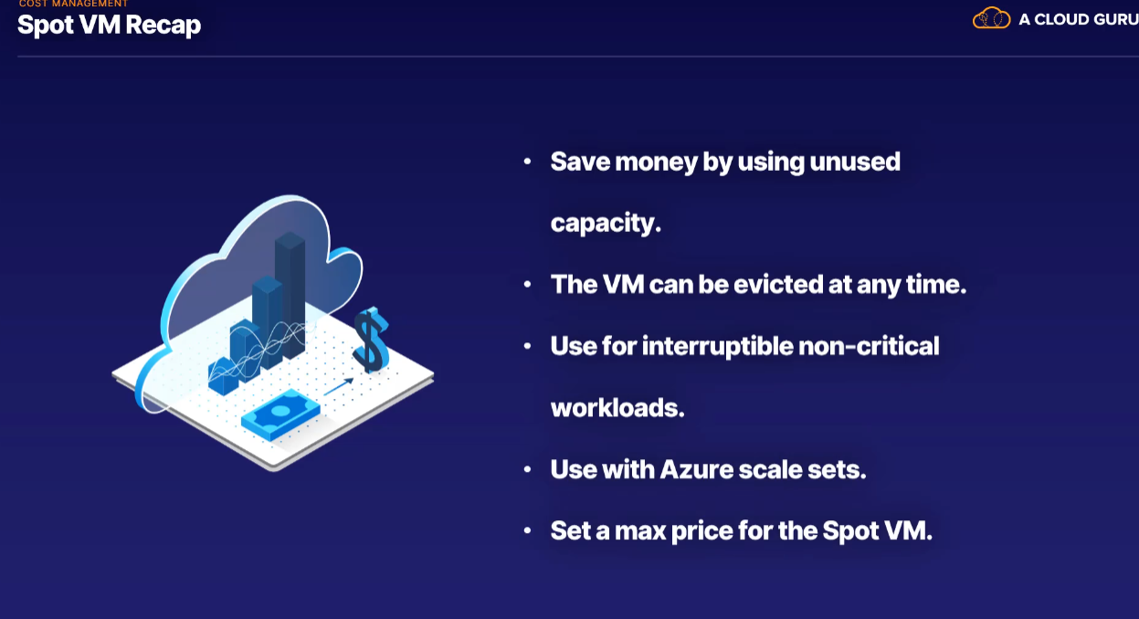

* Spot VMs save lots of cash by using unused computing capacity on Azure.
* You can lose the VM or be evicted (removed) at any time.
* Perfect for non-critical processing that can just start and stop and stop and start.
* You can use them with scale sets, and they're excellent for developmental testing,
* You can set a max price for the VM so you don't get caught out.

Pricing Factor:::

You'll have resources connected to each other, and quickly you lose track of how many dependencies are between various services.

Then, try and calculate which pricing is valid where and how much it will be. Impossible.



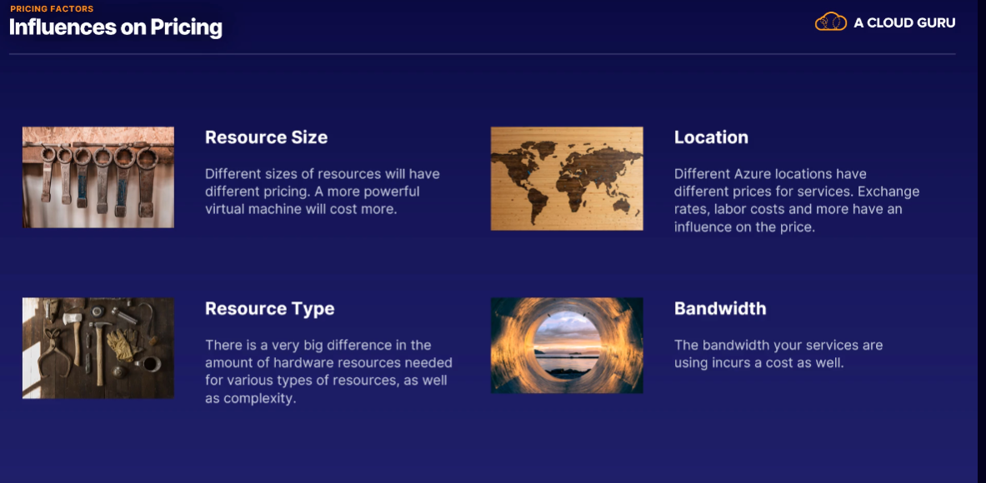

* Azure has three billing zones in the world.
* Each of these zones include many Azure regions.
* Any data transfer between Azure services located in the same zone is free.
* Any data transfer between two different billing zones is charged.
* Ingress - data in (free), egress- data out (not free)

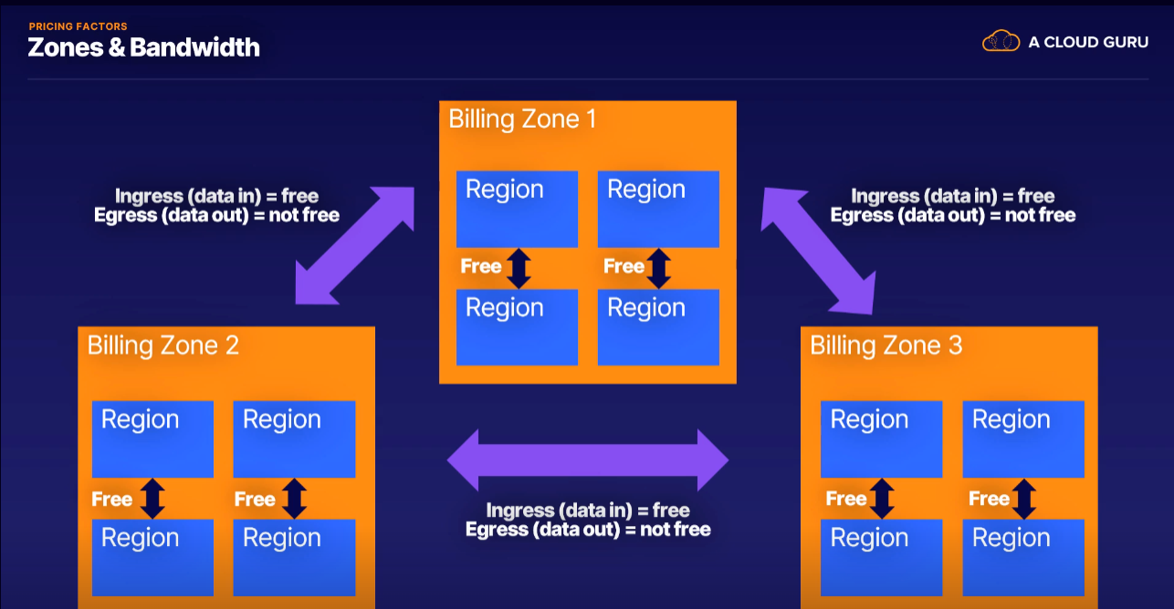

Based on all situations we can calculate the price, Microsoft has provided the Azure pricing calculator.

The calculator will estimate cost for almost any scenario you can think of.

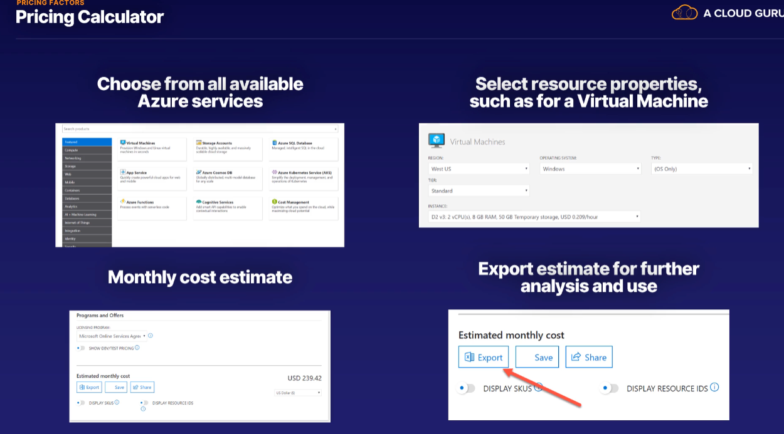

Knowing what the Azure monthly cost will be is great, but it doesn't answer the question of whether you'll be better off in the long run, compared to having your own infrastructure.

To calculate that price we have **Total Cost of Ownership Calculator**

This calculator lets you get an estimate of the total savings you could get for moving your on-premises service, storage, networks, databases, and much more.

Showcase the costs of saving on Azure.

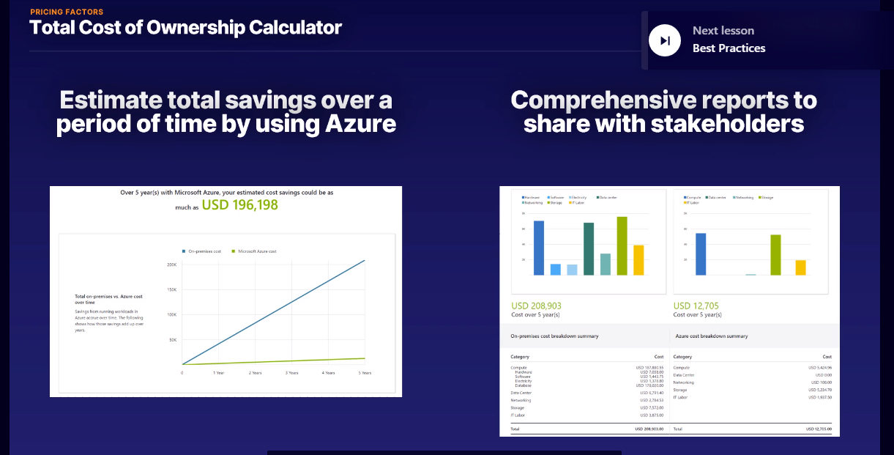

Best Practices

Spending Limits::

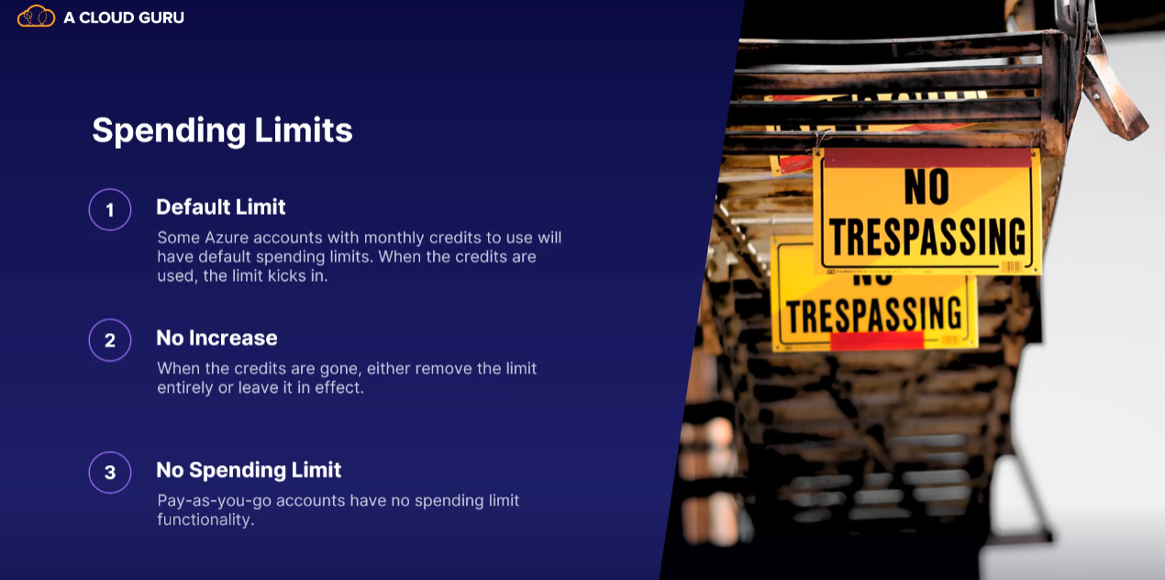

Quotas:::

Quotas are limits on certain properties of the resources.

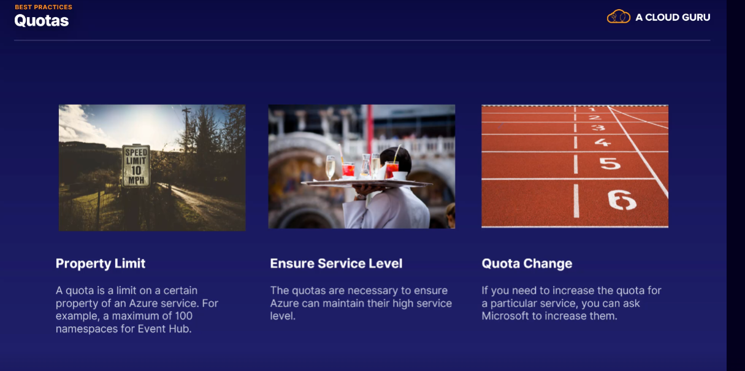

Tags:::

* Efficient way to manage where each resource belongs is using tags.
* Tags are non-functional labels you can attach to each resource group or resource.
* You can name the tags anything you want and attach as many to each resource as you wish.

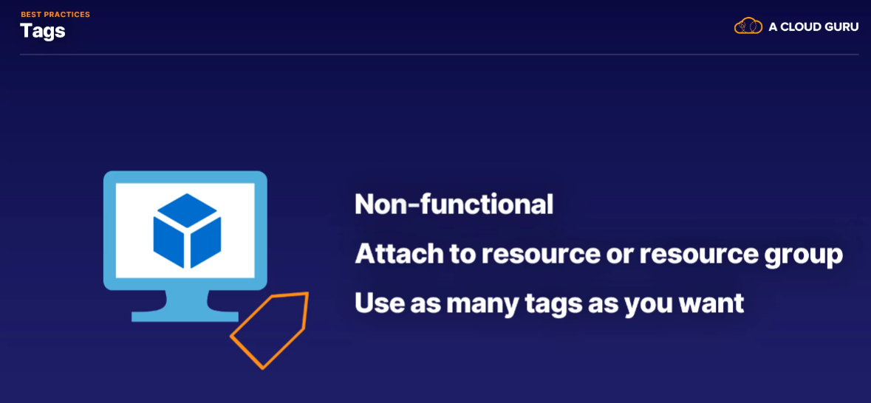

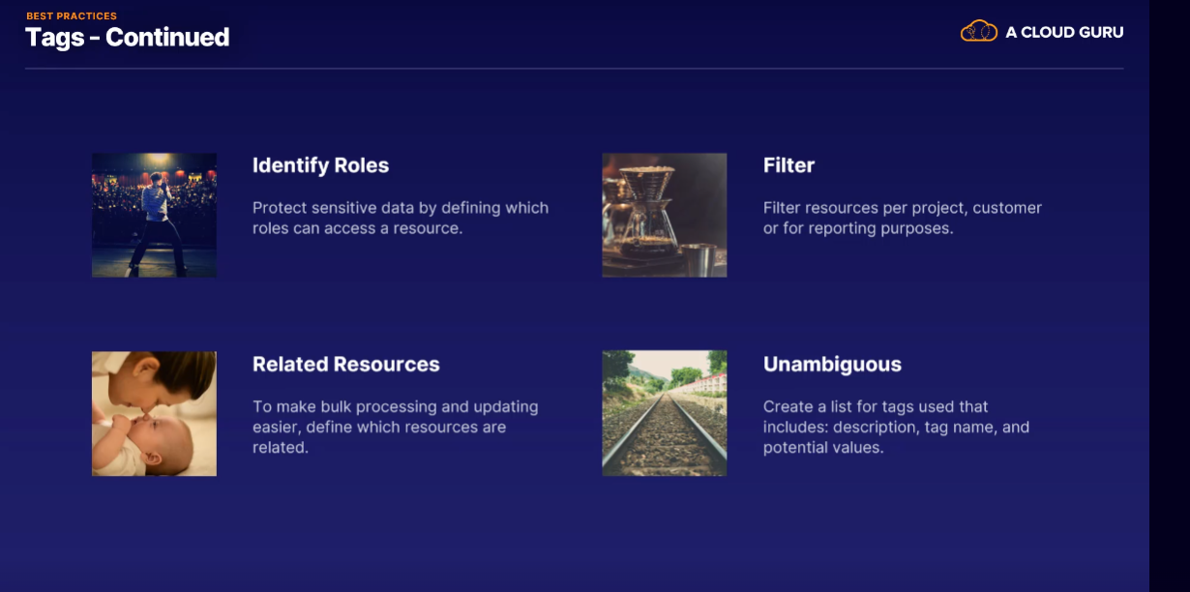

Pay- as – you – go

Using a pay-as-you-go model on Azure is very common as you only pay per month for what you use.

Reserved Instances :::::

**** Not all azure resources can be reserved **** (Mainly VMs are available)

It works like this….

"Hey, Azure, I'd like to reserve some virtual machines, for my use for a period of time."

"Certainly sir, would you like one or 3 years?"

"Eh, I'm thinking 3 years."

"Awesome, here's 70% off."

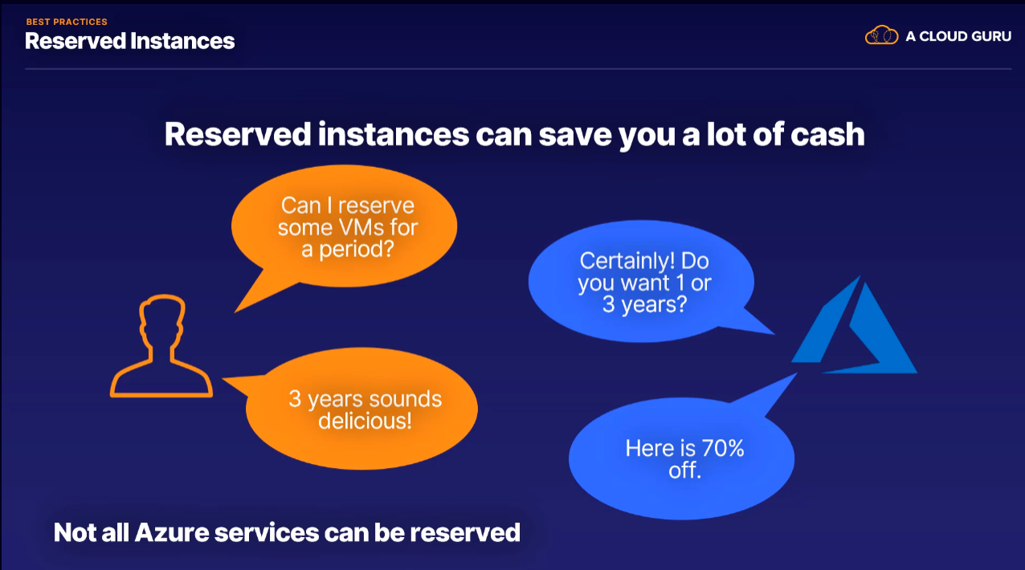

Reserved Capacity :::

Just like you can commit to using a VM for 1 or 3 years, Azure will also let you commit to using capacity for 1 or 3 years.

Available to

Azure SQL Database – 80%

Cosmos DB – 65%

Synapse Analytics – 65%

Redis Cache – 55%

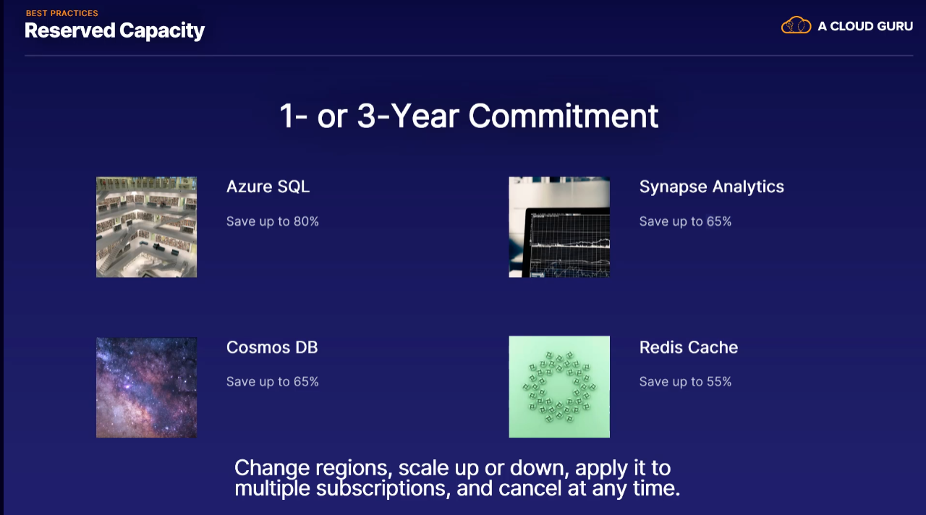

Azure Hybrid Benefit:::

Azure Hybrid Benefit is a way to save on VMs and SQL Server if you already have licenses for them.

It makes sense that Azure will let you use existing licenses instead of forcing you to purchase new ones with every new VM or server.

Microsoft has lots of maths and pie charts on how much money you can save as well, but it is essentially the cost of the license, obviously.

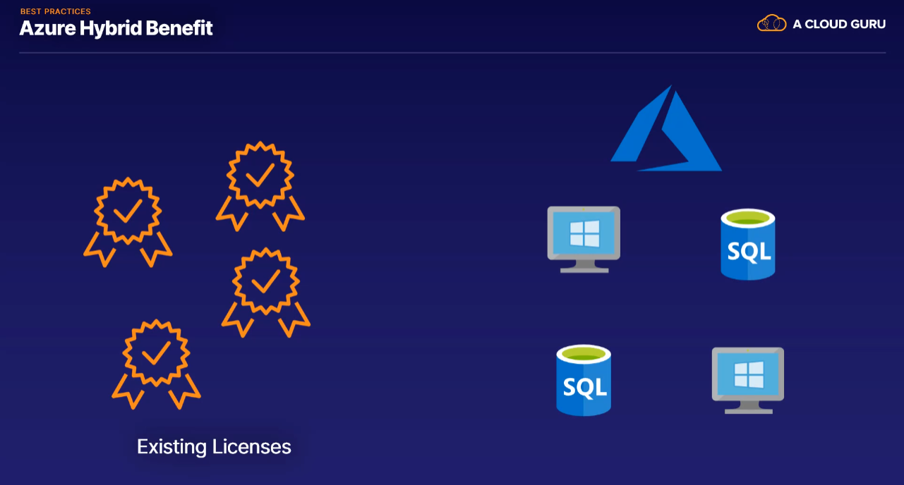

Advisor:::

Advisor tool is used for security and resource optimization, but it also has a cost optimization section.

The Advisor portal gives you best practices advice in general through recommendations.

For cost optimization, this could be a recommendation to scale down a virtual machine, removing networks you aren't using, and storage that is dormant.

